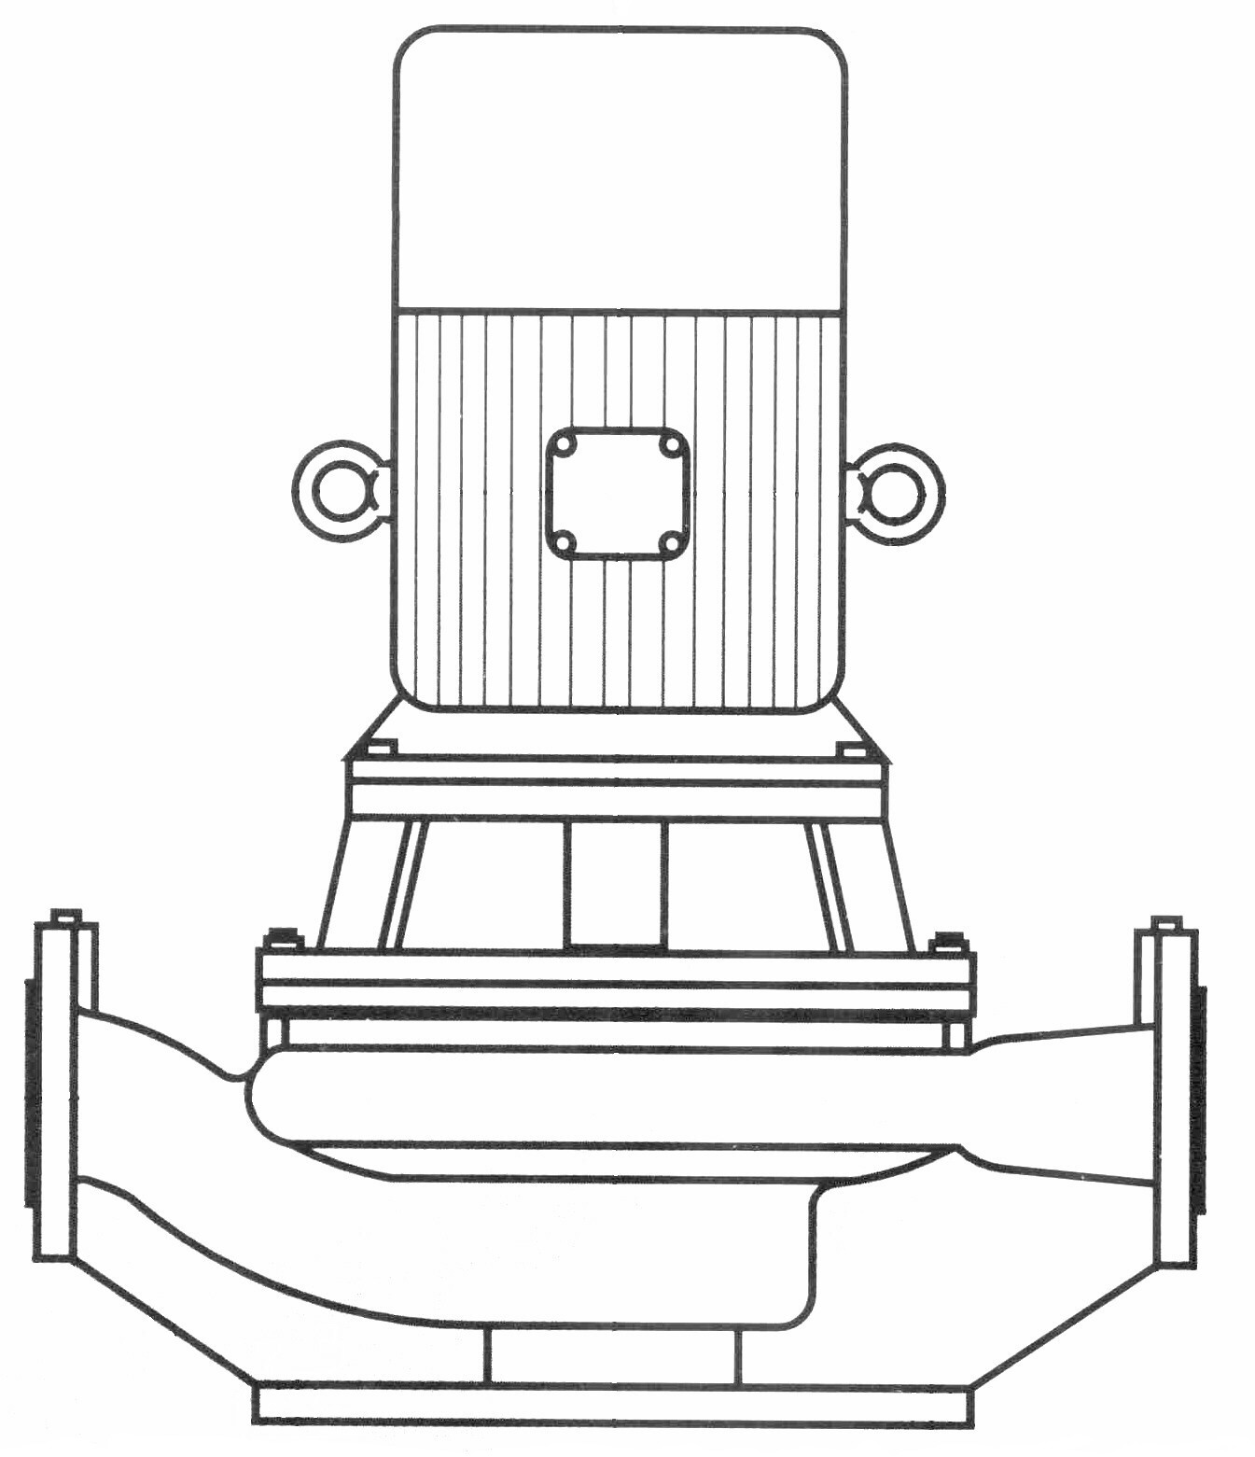

PRODUCT BULLETINMUNICIPALCOMMERCIALINDUSTRIAL
MODEL REI END SUCTIONQuench Water, Filtration, Transfer,HVAC, Booster, Condensate Return,Process, Petrochemical,
Filter Backwash, Supply WaterSupply Water, Reverse OsmosisLeachate Recovery
PRODUCT BULLETIN
MODEL REI END SUCTION
Bulletin 300REI
Edition 2c

American-Marsh Model REI End Suction pumps are used in a variety of industries. These rugged and efficient centrifugal pumps are designed for long life and low operational costs. Each model is of the back pull out design so when the need arises for repair or inspection, system piping does not need to be disturbed. REI models offer centerline suction and discharge and can be mounted in several different orientations. The REI product line surpasses other competitor product lines in that it spans sizes from 2” all the way up to 14” discharges.

Material Specifications
PART | CONSTRUCTION
PART | BRONZE FITTED | IRON FITTED | NI-RESIST FITTED | 316SS FITTED
Casing | Cast Iron | Cast Iron | Cast Iron | Cast Iron
Impeller | Bronze | Cast Iron | Ni-Resist | 316 Stainless Steel
Shaft | 420 Stainless Steel | 420 Stainless Steel | 420 Stainless Steel | 420 Stainless Steel
Shaft Sleeve | Bronze | Bronze | 316 Stainless Steel | 316 Stainless Steel
Case Wear Ring | Bronze | Cast Iron | Ni-Resist | 316 Stainless Steel
Bolts, Studs & Nuts | Steel | Steel | Steel | Steel
Mechanical Seal | Carbon/Si-C/Buna | Carbon/Si-C/Buna | Carbon/Si-C/Buna | Carbon/Si-C/Buna

MODEL REI SPECIFICATIONS

Casing: The casing is constructed of high tensile cast iron or other specified material. It is of the volute type, carefully and accurately proportioned to permit smooth flow and to convert high velocity energy of the fluid as it leaves the impeller into pressure. Suction and discharge nozzles are casted integral with the volute and are of 250 psi dimensions. All REI models feature a 250 psi case working pressure. The casing has a cast integral foot standard with the suction and discharge ports are on the same centerline. Necessary vent and drain openings are provided.

Impeller: The impeller is of the end suction type, casted in one piece of bronze or other specified material. All impellers are hydraulically and dynamically balanced prior to assembly and all impellers have pump out vanes standard on the back side of the imepller to reduce material from building up near the stuffing box.

Case Wear Ring: Standard enclosed impellers are designed with integral case wear rings accurately turned to provide close running fits in casing. The diameters of these rings are such as to reduce end thrust to a minimum. On larger models a rear case wear ring is provided for additional wear resistance.

Shaft: The shaft is of high strength 420 stainless steel, ground to accurate dimensions and polished to a smooth surface. It is designed for extra stiffness to avoid all critical speeds in operation. The shaft is protected by a shaft sleeve of ample thickness to ensure long life. The shaft sleeve can be supplied in various materials.

Casing Adapter: The casing adapter is constructed of cast iron or other specified material. The casing adapter houses the mechanical seal and has an integral flush line standard for stuffing box lubrication. When the casing assembly is supplied in optional material, the casing adapter is also constructed of the same material due to the fact it is also in contact with the pumped fluid.

Stuffing Box: The stuffing box is sized for a standard, front loading mechanical seal with integral flush line. The mechanical seal is constructed of a carbon rotary face, a ceramic stationary face and buna elastomers standard.

Motor: All REI models utilize standard, stocked, C-Face motors that are available in many different voltages, speeds and enclosures. Each motor can be removed from the unit without complete dissassembly of the pump. Also, pumps can be stocked complete, less driver and fully assembled ready for usage when the need arises. This flexibility allows the user more many additional options that JM motors do not offer. All REI models are driven by the motor keyway requiring no special machining or drilling operations.

Bulletin 300REI
Edition 2c

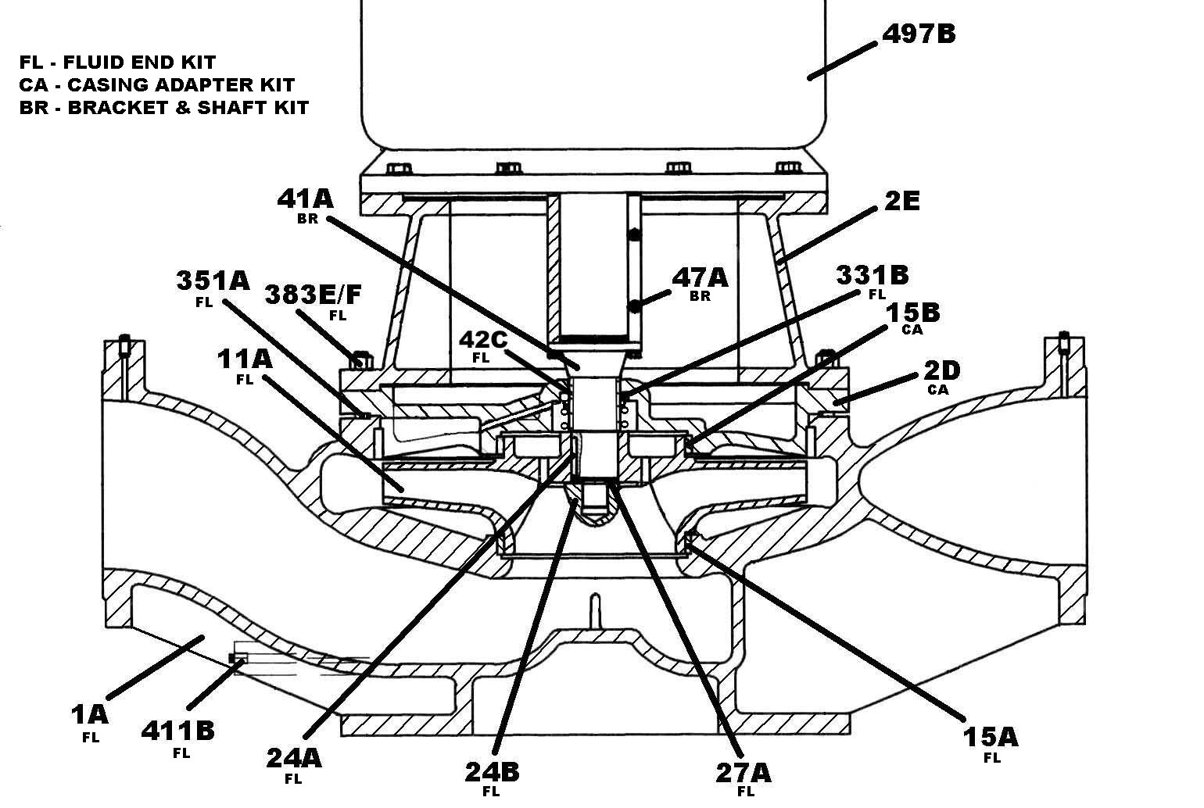

REI Sectional Drawing

Item Number | Item Description | Num. Req. |  | Item Number | Item Description | Num. Req.
1A | Casing | 1 |  | 41A | Shaft | 1
2D | Casing Adapter | 1 |  | 42C | Shaft Sleeve | 1
2E | Motor Bracket | 1 |  | 47A | Shaft Set Screw | Varies
11A | Impeller | 1 |  | 331B | Mechanical Seal | 1
15A | Case Wear Ring, Front | 1 |  | 351A | Casing Gasket | 1
15B | Case Wear Ring, Rear | Varies |  | 383E/F | Casing Stud & Nut | Varies
24A | Impeller Key | 1 |  | 411B | Plug, Drain | 1
24B | Impeller Nut | 1 |  | 497B | C-Face Motor | 1
27A | Impeller Washer | 1
Recommended spare parts are in BOLD.

